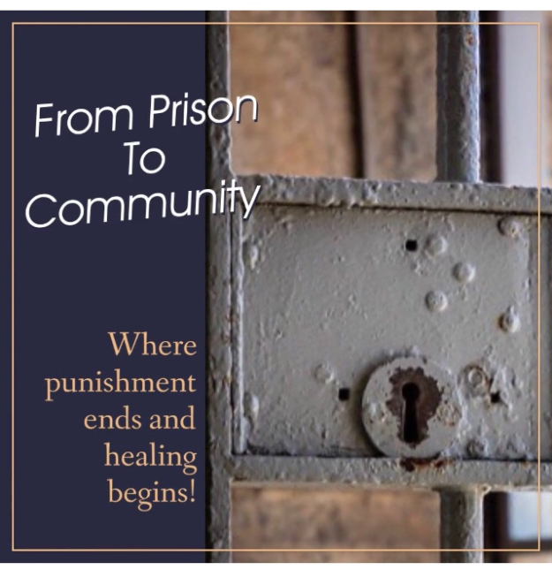

Transitional Housing Resources

California Department- Veterans - Website
1227 O Street, Sacramento, CA – Ph. 916-651-2147

2-1-1 Sacramento - Website
8001 Folsom Blvd, Sacramento, CA – Ph. 916-498-1000

Carmichael HART Winter Shelter - Website
5709 Cypress Avenue, Carmichael, CA – Ph.
(The intake site is located at the Church on Cypress. Dinner and a warm place to sleep will be provided at the host church.)

CSTL Clean And Sober Transitional Living - Website
8934 Madison Avenue, Fair Oaks, CA – Ph. 916-961-2691

Hope Center – Oroville - Website
1950 Kitrick Ave A, Oroville, CA – Ph. 530-538-8398

La Familia Counseling Center - Website
5523 34th Street, Sacramento, CA – Ph. 916-452-3601

Meadowview Community Action - Website
2251 Florin Road, Sacramento, CA – Ph. 916-399-9116
(Class of Housing: Emergency housing referral)

St. Vincent de Paul Society - Yuba City - Website
222 Clark Avenue, Yuba City, CA - Ph. 530-671-5154

Salvation Army- Grass Valley - Website
117 Neal Street, Grass Valley, CA – Ph. 530-477-1867

Salvation Army – Placerville - Website
899 Spring Street, Placerville, CA – Ph. 530-344-9178

Volunteers of America – Sacramento - Website
3434 Marconi Avenue, Sacramento, CA - Ph. 916-265-3400

